
Legionella pneumophila

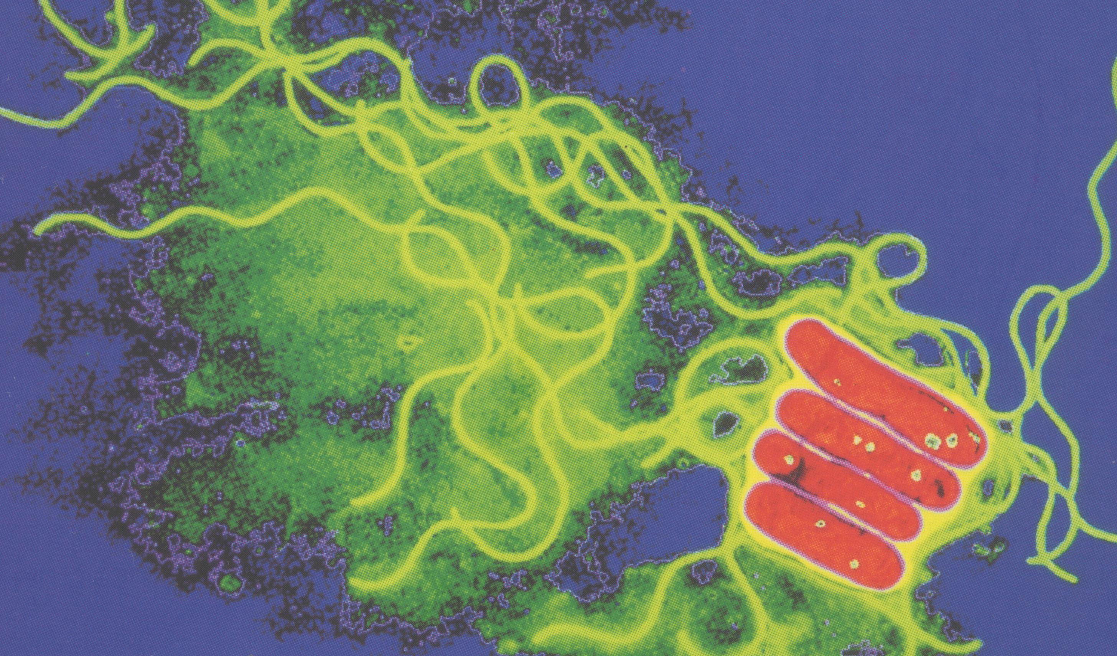
Legionnaires' disease is the severest form of infection caused by the bacterium Legionella pneumophila. It is the most well-known and serious form of a group of diseases known as legionellosis. Other similar (but usually less serious) conditions include Pontiac fever and Lochgoilhead fever.

Legionnaires' disease acquired its name in 1976 when an outbreak of pneumonia occurred among persons attending a convention of the American Legion in Philadelphia where 34 people died and 221 people became ill. Later, the bacterium causing the illness was isolated from lung tissue and subsequently named Legionella pneumophila.

Some people can be infected with the Legionella bacterium and have only mild symptoms or no illness at all.
Infection is caused by breathing in small droplets of water contaminated by the bacteria. The disease cannot be passed from one person to another.

Outbreaks of Legionnaires' disease receive significant media attention. However, this disease usually occurs as a single, isolated case not associated with any recognized outbreak. When outbreaks do occur, they are usually recognized in the summer and early autumn, but cases may occur year-round. About 5% to 30% of people who have Legionnaires' disease die.

Patients with Legionnaires' disease usually have fever, chills, and a cough, which may be dry or may produce sputum. Some patients also have muscle aches, headache, tiredness, loss of appetite, and, occasionally, diarrhoea. Laboratory tests may show that these patients' kidneys are not functioning properly. Chest X-rays often show pneumonia. It is difficult to distinguish Legionnaires' disease from other types of pneumonia by symptoms alone; other tests are required for diagnosis.
The time between the patient's exposure to the bacterium and the onset of illness for Legionnaires' disease is 2 to 10 days, but usually between 3 and 6 days.

People of any age may get Legionnaires' disease, but the illness in its’ severe form most often affects middle-aged and older persons, particularly those who smoke cigarettes or have chronic lung disease. Also at increased risk are persons whose immune system is suppressed by diseases such as cancer, kidney failure requiring dialysis, diabetes, or AIDS. Those that take drugs that suppress the immune system are also at higher risk.
Erythromycin is the antibiotic currently recommended for treating persons with Legionnaires' disease. In severe cases, a second drug, rifampin, may be used in addition. Other drugs are available for patients unable to tolerate erythromycin.

Outbreaks of legionellosis have occurred after persons have breathed mists that come from a water source (e.g., air conditioning cooling towers, whirlpool spas, showers) contaminated with Legionella bacteria. Persons may be exposed to these mists in homes, workplaces, hospitals, or public places. Legionellosis is not passed from person to person, and there is no evidence of persons becoming infected from vehicle air conditioners or household window air-conditioning units.

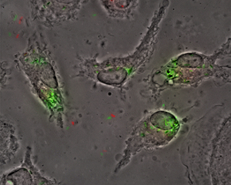
Legionella bacteria are common in natural water courses such as rivers and ponds. Since legionella are widespread in the environment, they may contaminate and grow in other water systems such as cooling towers, evaporative condensers of large air-conditioning systems, whirlpool spas and hot and cold water services. They survive low temperatures and thrive at temperatures between 20°C - 45°C if the conditions are right, e.g. if a supply of nutrients is present such as rust, sludge, scale, algae and other bacteria. They are killed by high temperatures. The bacteria reproduce rapidly to high numbers in warm, stagnant water at 32°- 41°C. Improved design and maintenance of cooling towers and plumbing systems to limit the growth and spread of Legionella organisms are the foundations of legionellosis prevention.

Businesses, public authorities and their managers have a legal duty, under the Health & Safety at Work Act 1974 and the Control of Substances Hazardous to Health Regulations 1999, to manage and control the risk of exposure to Legionella bacteria.

Failure to comply can and does lead to prosecution of individuals and organisations.

Duties under the law are:

Under general health and safety law, you have to consider the risks from legionella that may affect your staff or members of the public and take suitable precautions. As an employer or a person in control of the premises (e.g. a landlord), you must:

- identify and assess sources of risk
- prepare a scheme (or course of action) for preventing or controlling the risk
- implement and manage the scheme- appointing a person to be managerially responsible, some-times referred to as the ‘responsible person’
- keep records and check that what has been done is effective
- and, if appropriate, notify the local authority, in writing that you have a cooling tower(s) on site and where they are situated under the Notification of Cooling Towers and Evaporative Condensers Regulations
- You must also tell them when/if such devices are no longer in use. Notification forms are available from your local Environmental Health Department.

If you have a case of legionellosis in an employee who has worked on cooling towers or hot water systems that are likely to be contaminated with Legionella, you have to report this under the Reporting of Injuries, Diseases and Dangerous Occurrences Regulations.

On average there are 200-250 reported cases of Legionnaires’ disease in the UK each year. Outbreaks are often associated with cooling tower systems or hot and cold water systems.

Building managers are required to:

- Identify and assess the sources of risk
- Prepare a scheme for preventing or controlling the risk
- Appoint a person to be managerially responsible
- Implement and manage precautions
- Keep records of the precautions implemented
The risk assessment is the responsibility of the employer or person in control of the premises. You may be able to carry out the assessment yourself but, if not, you should call on help and advice from within your own organisation or if this is not available, from outside sources, e.g. consultancies. You need to find out if your water systems (including the equipment associated with the system such as pumps, heat exchangers, showers etc) are likely to create a risk. Ask yourself the following:
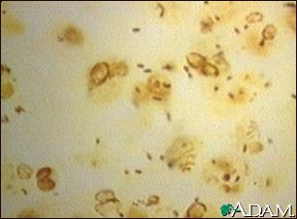

- Are conditions present which will encourage bacteria to multiply? For example - is the water temperature between 20-45°C?
- Is it possible that water droplets will be produced and, if so, could they be dispersed over a wide area? For example, consider showers and aerosols from cooling towers
- Is it likely that anyone particularly susceptible will come into contact with the contaminated water droplets?

If you decide that the risks are insignificant, your assessment is complete. You need take no further action other than to review the assessment periodically in case anything changes in your system.

If a risk is identified which cannot be prevented, you must introduce proper controls. Risks from legionella in water systems can be controlled but careful planning, a successful management policy, competent staff and attention to proper control strategies are all essential.

You should consider whether you can prevent the risk of legionella in the first place by looking at the type of waters system you need. For example, is it possible to replace a wet cooling tower with a dry air cooled system? You need to prepare a written scheme which sets out how you intend to control the risk from Legionella. You should describe:

- your system - an up-to-date plan or schematic diagrams are sufficient
- who is responsible for carrying out the assessment and managing its implementation
- the safe and correct operation of your system
- what control methods and other precautions you will be using
- what checks that will be carried out on the control scheme and how often these checks will be carried out.

The key point is to design, maintain and operate your water services under conditions which prevent or control the growth and multiplication of Legionella.

You should:

- ensure that the release of water spray is properly controlled
- avoid water temperatures and conditions that favour the growth of legionella and other micro-organisms
- ensure water cannot stagnate anywhere in the system by keeping pipe lengths as short as possible or by removing redundant pipe work
- avoid materials that encourage the growth of Legionella
- keep the system and the water in it clean
- treat water to either kill Legionella (and other micro-organisms) or limit their ability to grow.

Keeping the water in a cooling tower system clean will not only control legionella, but also lead to other advantages. By reducing scale and fouling, you are also ensuring that the cooling process is operating efficiently – scaling reduces the effectiveness of biocide treatment and fouling can lead to loss of plant performance.

Cooling towers/systems are often treated using a wide range of biocides. But there are other treatment strategies available such as ultra-violet (UV) irradiation, copper/silver ionisation and ozone. In hot and cold water systems legionella has traditionally been controlled by storing hot water above 60°C and distributing it at above 50°C -and keeping cold water below 20°C if at all possible. Other methods which are used include chlorinisation and chlorine dioxide.
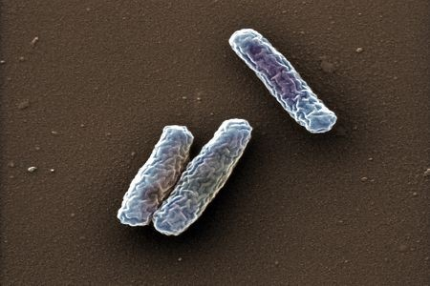
One way of controlling Legionella is to keep water hot, which you may be doing for other reasons already. For example, nursing homes and residential care homes tend to keep water hot for reasons other than controlling legionella, including kitchen and laundry use, to ensure proper boiler operation, or to take account of long pipe runs. However, care is needed where water runs hot. The risks of scalding should be assessed and appropriate measures taken to prevent burns, e.g. warning notices and thermostatic mixing valves on taps.

But whatever treatment method you use, you need to make sure you know:

- what the effective level of control is for your system, e.g. temperature and concentration of biocides
- if the treatment method can cope with changes in the system, e.g. variations in the amount of water used throughout the day
- how you are going to measure the effectiveness of the treatment method; for example, if you are using temperature as a control method you can take the temperature of the water coming out of the taps.

Sampling and testing for the presence of Legionella bacteria is just one way of checking that your system is under control. But it is not a simple test - sampling and detecting legionella requires specialist help. There are a number of Class 1 laboratories that are qualified to test for Legionella pneumophila. The charges for these tests are not too high and you should be supplied with sterile sample bottles.

You need to appoint someone to take responsibility for managing the control scheme that you have put in place. The ‘responsible person’ needs to be competent - that is, they need to have sufficient knowledge and experience of your system to enable them to manage and control the scheme effectively.

If there are several people responsible for managing the system and/or control scheme, for example because of shift-work patterns, you need to make sure that everyone knows what they are responsible for and how they fit into the overall management of the system.

If you decide to employ contractors to carry out water treatment or other work, it is still the responsibility of the appointed person to ensure that the treatment is carried out to the required standards.

And remember, before you employ a contractor, you should be satisfied that they can do the work you want to the standard that you require.

If you employ five or more people you must record the significant findings of your risk assessment. This means writing down the significant findings of the assessment and details of any monitoring or checking carried out. If you have fewer than five employees you do not need to write anything down, although it is useful to keep a written record of what you have done. You also need to keep records of your written scheme and who is responsible for managing that scheme. You should also keep the results of your routine monitoring. You need to keep these records for a minimum of five years.

Anyone who is involved in the supply of water systems and their components (e.g. designers, manufacturers, water treatment companies and suppliers) has to make sure that such equipment is designed and made in such a way that it is safe to use at work and that it can be easily cleaned and maintained.
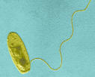
They should tell you what risks might be present and how you can operate and maintain the system safely.

If you are using products or services, for example, for water treatment, the suppliers must make sure that these are effective at controlling legionella and that they can be used safely at work. They should also tell you if, while they are treating your system, they find any problems which could pose a significant risk of Legionella exposure.

Local authorities have special plans for dealing with major outbreaks of infectious disease including legionellosis. These are usually investigated by an Outbreak Control Team whose purpose is to protect public health and prevent further infection. HSE or the local authority Environ-mental Health Department may also be involved in investigating compliance with health and safety legislation.

Table 1, typical on-site monitoring checks recommended for good operating practice

Parameter | Timing
 | Make up-water | Cooling water
Calcium hardness as mg/l CaCO₃ | Monthly | Monthly
Magnesium hardness as mg/l CaCO₃ | Monthly | Monthly
Total hardness as mg/l CaCO₃ | Monthly | Monthly
Total alkalinity as mg/l CaCO₃ | Quarterly | Quarterly
Chloride as mg/l Cl | Monthly | Monthly
Sulphate as mg/l SO₄ | Quarterly | Quarterly
Conductivity in μS (Total dissolved solids) | Monthly | Weekly
Suspended solids mg/l | Quarterly | Quarterly
Inhibitor(s) level mg/l | - | Monthly
Oxidising biocide mg/l | - | Weekly
Temperature °C | - | Quarterly
pH | Quarterly | Weekly
Soluble iron as mg/l Fe | Quarterly | Quarterly
Total iron as mg/l Fe | Quarterly | Quarterly
Concentration factor | - | Monthly
Microbiological activity | Quarterly | Weekly
Legionella | - | Quarterly

The identification of changes in the water chemistry such as pH, dissolved and suspended solids, hardness, chloride and alkalinity allows any necessary corrective actions to be taken to the treatment programme or system operating conditions. In addition, chemical treatment reserves such as scale and corrosion inhibitors and oxidising biocides should be measured. Routine on-site determination of the concentration of non-oxidising biocides is not practical. The amount of non-oxidising biocide required is therefore calculated from the volume and half-life of the system. Other aspects of the treatment programme such as corrosion rates and microbiological activity will also need to be monitored.

The monitoring programme should also include the routine sampling and testing for the presence of bacteria, both general (aerobic) bacterial species and Legionella bacteria. Since the detection of Legionella bacteria requires specialist laboratory techniques, routine monitoring for aerobic bacteria is used as an indication of whether microbiological control is being achieved.
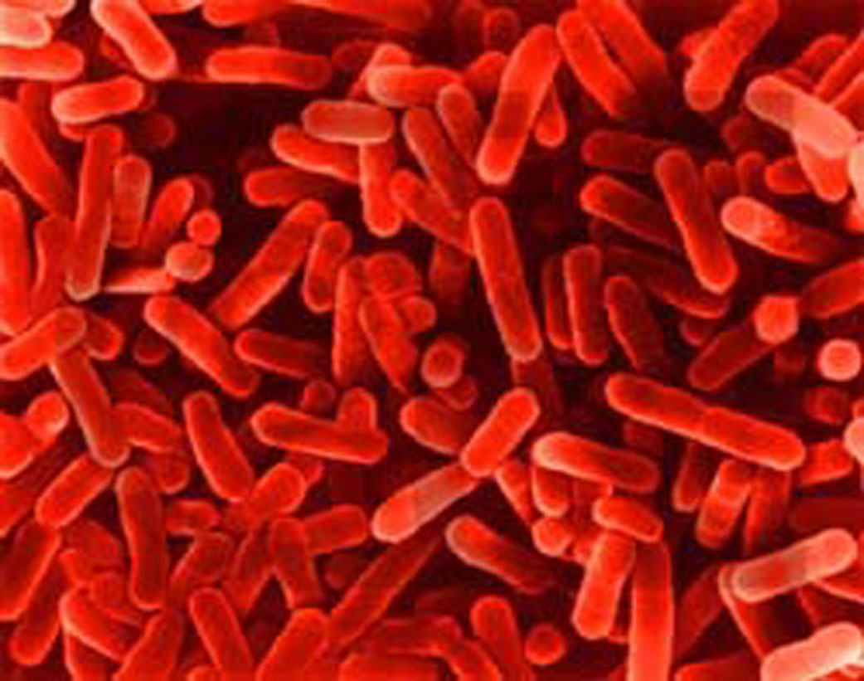
The most common method to measure microbiological activity within a cooling system is to use a dip slide. These are commercially available plastic slides which are coated with sterile nutrient agar - a medium on which many micro-organisms will grow, but not Legionella. They are dipped into the water and incubated for 48 hours. Any bacteria in the cooling water will grow and form colonies. Comparison with a chart will indicate the number of bacteria in the water. Dip slides should be dipped in the system water as near to the heat source as possible. If a drain cock is used it is important that any residual water is run off before the slide is dipped. The dip slide should then be replaced into its container and incubated for a minimum of 48 hours in an incubator, usually at 30°C. The incubation period and the temperature should be the same each time the test is performed.

Cooling tower water should be tested, using dip slides (or similar), on a weekly basis. The timing of dip slides and other microbiological sampling is important. Sampling should not be carried out if biocide has been recently added. Neither should the visible condition of the water be taken as a good indicator of the need for sampling; there are a number of chemical additions which render the water opaque. Conversely, relatively clear water may be heavily contaminated with bacteria.

Table 2 lists microbiological counts and the appropriate action that should be taken in response to them. While the number of micro-organisms is itself important, it is also necessary to monitor any changes from week-to-week, particularly if there are any increases in the numbers of micro-organisms detected. This should always result in a review of the system and the control strategies. A graphical representation of these data will often help to monitor any trends.

If the control strategy is effective, the dip slide counts should be consistently low. If an unusually high result is obtained, the test should be repeated immediately and, if confirmed, appropriate action taken (see Table 2). Consistently high microbiological counts using dip slides should be checked by laboratory-based total viable counts (TVC). The laboratory should be accredited by the United Kingdom Accreditation Service (UKAS)

Table 2: Action levels following microbial monitoring for cooling towers

AEROBIC COUNT | LEGIONELLA BACTERIA | ACTION REQUIRED
cfu/ml at 30°C (minimum 48 hours incubation) | cfu/litre
10,000 or less | 100 or less | System under control
more than 10,000 and up  to 100,000 | more than 100 and up to 1,000 | Review programme operation - A review of the control measures and risk assessment should be carried out to identify any remedial actions and the count should be confirmed by immediate re-sampling.
more than 100,000 | more than 1,000 | Implement corrective action - The system should immediately be re-sampled. It should then be `shot dosed' with an appropriate biocide, as a precaution. The risk assessment and control measures should be reviewed to identify remedial actions.

Alternative techniques for determining microbiological activity have been developed for on-site use. It is important that such methods can be clearly related to the results achieved by traditional counting methods and that appropriate action levels can be set to inform decisions on the necessary control measures.
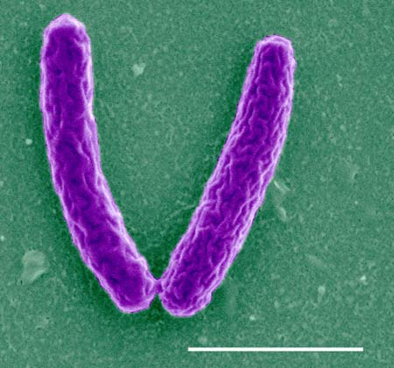
Monitoring for Legionella

In addition to the routine sampling for aerobic bacteria, the routine monitoring scheme should also include periodic sampling for the presence of Legionella bacteria. This should be undertaken at least quarterly, unless sampling is necessary for other reasons, such as to help identify possible sources of the bacteria during outbreaks of Legionnaires' disease. More frequent sampling should be carried out when commissioning a system and establishing a treatment programme. Sampling should be carried out, on a monthly basis, until it can be shown that the system is under control. If a Legionella-positive sample is found as a result of routine sampling, more frequent samples may be required as part of the review of the system/risk assessment, to help establish when the system is back under control. The sampling method should be in accordance with ISO 11731:1998⁸ and the biocide neutralised where possible. Samples should be taken as near to the heat source as possible. They should be tested by a UKAS accredited laboratory that takes part in the Public Health Laboratory Service Water Microbiology External Quality Assessment Scheme for the isolation of legionella from water. The laboratory should also apply a minimum theoretical mathematical detection limit of less than, or equal to, 100 Legionella bacteria per litre of sample.

Legionella bacteria are commonly found in almost all natural water sources, so sampling of water systems and services may often yield positive results and the interpretation of any results of sampling should be carried out by experienced microbiologists. Failure to detect Legionella bacteria should not lead to the relaxation of control measures and monitoring. Neither should monitoring for the presence of legionella bacteria in a cooling system be used as a substitute in any way for vigilance with control strategies and those measures identified in the risk assessment.

Cleaning and disinfection

The ACOP says the risk from exposure to Legionella should be prevented or controlled; precautions include maintaining the cleanliness of the system and the water in it. The following section on cleaning and disinfection offers guidance on how to do this in cooling systems.

The maintenance of an effective biocide regime will provide a hostile environment for microbial life (including Legionella) and minimise biofouling. However, the use of biocides should not be considered in isolation but as part of the overall water treatment programme including the manual and chemical cleaning and disinfection of open cooling systems, and in particular the cooling tower.

Many cooling systems operate on a continuous basis where process conditions preclude total system shutdown except infrequently. Other measures, such as side-stream filtration, more frequent microbiological monitoring, continuous biocide addition etc, which are reasonably practicable, should be applied and monitored carefully.

Disinfection, cleaning and manual desludging of cooling towers should be undertaken at least twice a year, but more frequent cleaning may be necessary depending on local environmental conditions such as dirty atmospheres and the conclusions reached in the risk assessment. Cooling systems that have a short operating period may only need to be cleaned at the beginning and end of that period. If on inspection the system shows signs of a significant build-up of deposits or slime, then disinfection and cleaning should be carried out. The use of chlorine or other oxidising biocides to disinfect the tower is an effective approach, provided they are used correctly.
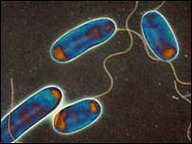
In addition to this regular disinfection, cooling towers should always be cleaned and disinfected before being put back into service:
- immediately before the system is first commissioned;
- after any prolonged shutdown of a month or longer (a risk assessment may indicate the need for cleaning and disinfection after a period of less than one month, especially in summer and for health care premises where shutdown is for more than five days);
- if the tower or any part of the cooling system has been mechanically altered;
- if the cleanliness of the tower or system is in any doubt; and
- if microbiological monitoring indicates that there is a problem.

Routine cleaning and disinfection

Pre-cleaning disinfection- The system water should be disinfected using an oxidising biocide such as chlorine, bromine or chlorine dioxide to minimise health risks to the cleaning staff. This is done by adding either sodium hypochlorite solution or chloroisocyanurate compounds available as rapid release tablets to achieve a measured residual of 5 mg/l free chlorine. Sodium hypochlorite solutions typically contain 10-12% available chlorine and rapid release tablets contain 50-55% available chlorine. Such products should be handled with care and according to instructions given by the supplier. A biodispersant should also be used to enhance the effectiveness of the chlorination.

The chlorinated water containing 5 mg/l free chlorine should be circulated through the system for a period of 5 hours with the fan off, maintaining a minimum of 5 mg/l free chlorine at all times. However, if the system pH value is greater than 8.0, the measured residual will need to be in the range 15-20 mg/l free chlorine in order to achieve the required disinfection level. An alternative procedure to provide more effective use of chlorine is to introduce a heavy bleed-off for several hours to both reduce the pH of the system water and its chlorine demand, before carrying out disinfection. The system should then be de-chlorinated (see paragraph 144) and drained.

Cleaning - Manual cleaning operations can then be carried out, with all accessible areas of the tower etc being adequately cleaned. Where practicable, the packs should be removed at least once a year and preferably every six months. If this is not practicable, it may be necessary to apply supplementary strategies such as side-stream filtration, increased monitoring etc. Accessible areas of the tower and its pack should be adequately washed but cleaning methods that create excessive spray, for example high-pressure water jetting, should be avoided. If this is not possible, the operation should be carried out when the building is unoccupied or, in the case of permanently occupied buildings, windows in the vicinity should be closed, air inlets blanked off and the area that is being water-jetted should be tented. The area should be isolated and consideration should also be given to other occupied premises in the immediate areas as well as members of the public who may in the vicinity during cleaning.

Cleaning staff who carry out water-jetting should wear suitable respiratory protective equipment such as a positive-pressure respirator with full face-piece or a hood and blouse. Staff who use this equipment should be adequately trained and the equipment properly maintained (see section on protection of personnel in paragraphs 199-202).

Adherent scale or other deposits on the tower and distribution system that have not been removed by the above method can be dissolved using chemical descalents carefully chosen
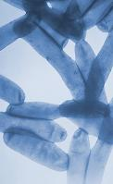
to avoid damage to the fabric of the system. If this is not possible, routine inspection and testing of water quality should be particularly thorough.

Finally, the system should be sluiced out until the water going to drain is clear.

Post-cleaning disinfection - On completion of the cleaning operation, the system should be refilled and chlorinated to maintain a minimum level of 5 mg/l of free chlorine for a period of 5 hours with the fan off. This needs to be checked hourly to ensure that a concentration of 5 mg/l is present for the total period. Again, the use of a biodispersant will enhance the effectiveness of this chlorination. If the system volume is greater than 5m³, the water should be de-chlorinated, drained, flushed and refilled with fresh water and dosed with the appropriate start-up level of treatment chemicals, including the biocides.

While the maintenance of a continuous minimum residual of 5 mg/l of free chlorine for a minimum period of 5 hours is considered the best practice, if the downtime to conduct such a lengthy operation is not available, some compromise may be necessary. Under such circumstances it may be acceptable to shorten the pre- and post-chlorination times and to increase the free chlorine level, e.g. 50 mg/l for 1 hour or 25 mg/l for 2 hours. This should only be done if the operators are trained in this process because, at these levels, there is a greater risk of damaging the fabric of the system. The system should then be de-chlorinated, drained, flushed and refilled with fresh water and dosed with the appropriate start-up level of treatment chemicals, including the biocides.

Before water containing high-residual free chlorine is discharged to drain, it should be de-chlorinated. The usual procedure is to add sodium thiosulphate, sodium sulphite or sodium bisulphite as a neutraliser. The level of free chlorine is determined by testing and the quantity of sodium salt then is calculated.

Recommended inspection frequencies for risk systems

Checklist 1: Cooling water installations
System/service | Task | Frequency
Cooling towers and  evaporative condensers | Monitor water quality, water use and biocide/chemical use to assess and ensure effectiveness of water treatment regime, including key chemical and microbiological parameters, and observations of internal condition of pond, pack and water | See Table 1
Cooling towers and  evaporative condensers | Central control function, conductivity sensor calibration, blowdown function, uniformity of water distribution, condition of sprays/troughs, eliminators, pack, pond, immersion heater, fans and sound attenuators | Monthly to three monthly, according to risk (See Table1)
Cooling towers and  evaporative condensers | Clean and disinfect cooling towers/evaporative condensers, make-up tanks and associated systems, including all wetted surfaces, descaling as necessary. Packs should be removed and cleaned where practicable | Six monthly

Checklist 2: Hot and cold water services
Service | Task | Frequency
Hot water services | Arrange for samples to be taken from hot water calorifiers, in order to note condition of drain water | Annually
Hot water services | Check temperatures in flow and return at calorifiers | Monthly
Hot water services | Check water temperature up to one minute to see if it has reached 50°C in the sentinel taps | Monthly
Hot water services | Visual check on internal surfaces of calorifiers for scale and sludge. Check representative taps for temperature as above on a rotational basis | Annually
Cold water services | Check tank water temperature remote from ball valve and mains temperature at ball valve. Note maximum temperatures recorded by fixed max/min thermometers  where fitted | Six monthly
Cold water services | Check that temperature is below 20°C after running the water for up to two minutes in the sentinel taps | Monthly
Cold water services | Visually inspect cold water storage tanks and carry out remedial work where necessary. Check representative taps for temperature as above on a rotational basis | Annually
Shower heads | Dismantle, clean and descale shower heads and hoses | Quarterly or as necessary
Little-used outlets | Flush through and purge to drain, or purge to drain immediately before use, without release of aerosols | Weekly

Checklist 3: Other risk systems
System/service | Task | Frequency
Ultrasonic Humidifiers / foggers and water misting  systems | If equipment fitted with UV lights, check to ensure effectiveness of lamp (check to see if within working life) and clean filters | Six monthly or according to manufacturer's  instructions
Ultrasonic Humidifiers / foggers and water misting  systems | Ensure automatic purge of residual water is functioning | As part of machinery shut down
Ultrasonic Humidifiers / foggers and water misting  systems | Clean and disinfect all wetted parts | As indicated by risk assessment
Ultrasonic Humidifiers / foggers and water misting  systems | Sampling for legionella | As indicated by risk assessment
Spray humidifiers, air washers and wet scrubbers | Clean and disinfect spray humidifiers/air washers and make-up tanks including all wetted surfaces, descaling as necessary | Six monthly
Spray humidifiers, air washers and wet scrubbers | Confirm the operation of non-chemical water treatment (if present) | Weekly
Water softeners | Clean and disinfect resin and brine tank - check with manufacturer what chemicals can be used to disinfect resin bed | As recommended by manufacturer
Emergency showers and eye wash sprays | Flush through and purge to drain | Six monthly or more frequently if recommended  by manufacturers
Sprinkler and hose reel systems | When witnessing tests of sprinkler blow - down and hose reels ensure that there is minimum risk of exposure to aerosols | As directed
Lathe and machine tool coolant systems | Clean and disinfect storage and distribution system | Six monthly
Spa baths | Check filters - sand filters should be backwashed daily | Daily
Spa baths | Check water treatment - pools should be continuously treated with an oxidizing biocide | Three times daily
Spa baths | Clean and disinfect entire system | Weekly
Horticultural misting systems | Clean and disinfect distribution pipe work, spray heads and make-up tanks including all wetted surfaces, descaling as necessary | Annually
Dental equipment | Drain down and clean | At the end of each working day
Car/bus washes | Check filtration and treatment system, clean and disinfect system | See manufacturers'  instructions
Indoor fountains  and water features | Clean and disinfect ponds, spray heads and make-up tanks including all wetted surfaces, descaling as necessary | Interval depending on  condition

Action in the event of an outbreak
(from HSE L8)

1 Legionnaires' disease is not notifiable under public health legislation in England and Wales but, in Scotland, legionellosis (i.e. all diseases caused by Legionella) is notifiable under the Public Health (Notification of Infectious Disease) (Scotland) Regulations 1988.

2 An outbreak is defined by the Public Health Laboratory Service (PHLS) as two or more confirmed cases of legionellosis occurring in the same locality within a six-month period. Location is defined in terms of the geographical proximity of the cases and requires a degree of judgement. It is the responsibility of the Proper Officer for the declaration of an outbreak. The Proper Officer is appointed by the local authority under public health legislation and is usually a Consultant in Communicable Disease Control (CCDC). In Scotland, it is the Consultant in Public Health Medicine (CPHM) employed by the Health Board and acting as Designated Medical Officer for the local authority.

3 Local authorities will have established incident plans to investigate major outbreaks of infectious disease including legionellosis. These are activated by the Proper Officer who invokes an Outbreak Committee, whose primary purpose is to protect public health and prevent further infection. This will normally be set up to manage the incident and will involve representatives of all the agencies involved. HSE or the local authority EHO may be involved in the investigation of outbreaks, their aim being to pursue compliance with health and safety legislation.

4 The local authority, CCDC or EHO acting on their behalf (often with the relevant officer from the enforcing authorities - either HSE or the local authority) may make a site visit.

5 As part of the outbreak investigation and control, the following requests and recommendations may be made by the enforcing authority.

(a) To shut down any processes which are capable of generating and disseminating airborne water droplets and keep them shut down until sampling procedures and any remedial cleaning or other work has been done. Final clearance to restart the system may be required.

(b) To take water samples from the system before any emergency disinfection being undertaken. This will help the investigation of the cause of the illness. The investigating officers from the local authorities may take samples or require them to be taken.

(c) To provide staff health records to discern whether there are any further undiagnosed cases of illness and to help prepare case histories of the people affected.

(d) To co-operate fully in an investigation of any plant that may be suspected of being involved in the cause of the outbreak. This may involve, for example:

(i) Tracing of all pipe work runs;

(ii) Detailed scrutiny of all operational records;

(iii) Statements from plant operatives and managers;

(iv) Taking statements from water treatment contractors or consultants.

6 Any infringements of relevant legislation may be subject to a formal investigation by the appropriate enforcing authority.

Emergency cleaning and disinfection procedure for cooling towers

7 If a cooling water system has been implicated in an outbreak of Legionnaires' disease emergency cleaning of that system has to take place as soon as possible. The following actions should be taken, where appropriate:

(a) Switch off the fan immediately;

(b) Take samples for laboratory investigation before any further action;

(c) Switch off the circulation pump as soon as is practicable and the system decommissioned;

(d) Consult the enforcing authority before proceeding further;

(e) Keep all personnel clear of the tower area, when cleared by the enforcing authority, add sodium hypochlorite to the system water to obtain a measured concentration of 50 mg/l of free chlorine;

(g) Circulate the system water with the fans off for a period of at least six hours,

(h) Maintain the free chlorine level at an absolute minimum of 20 mg/l at all times; use a suitable biodispersant; after six hours, de-chlorinate and drain the system;

(k) Undertake manual cleaning of the tower, sump, and distribution system with cleaning staff wearing fully pressurised respirators; refill with fresh water, add sodium hypochlorite; recirculate without using the fan, at 20 mg/1 of free available chlorine for six hours;

(n) De-chlorinate and drain the system;

(o) Refill, recirculate and take samples for testing: re-commission system when test results detect no legionella and/or permission is granted by the enforcing authority.

8 If a water system other than a cooling system is implicated in an outbreak of Legionnaires' disease, emergency treatment of that system should be carried out as soon as possible.

